
ROAD TRAFFIC REGULATION ACT 1984 – SECTION 14(2)

Temporary Closure of Footpath 4 Cressing

NOTICE IS HEREBY GIVEN that from the date specified below, the Essex County Council has temporarily closed to all pedestrians under section S14(2) of the Road Traffic Regulation Act 1984 (as amended), Footpath 4, Cressing, in the District of Braintree, from the junction with B1018 Braintree Road, southeast for approximately 450 metres.
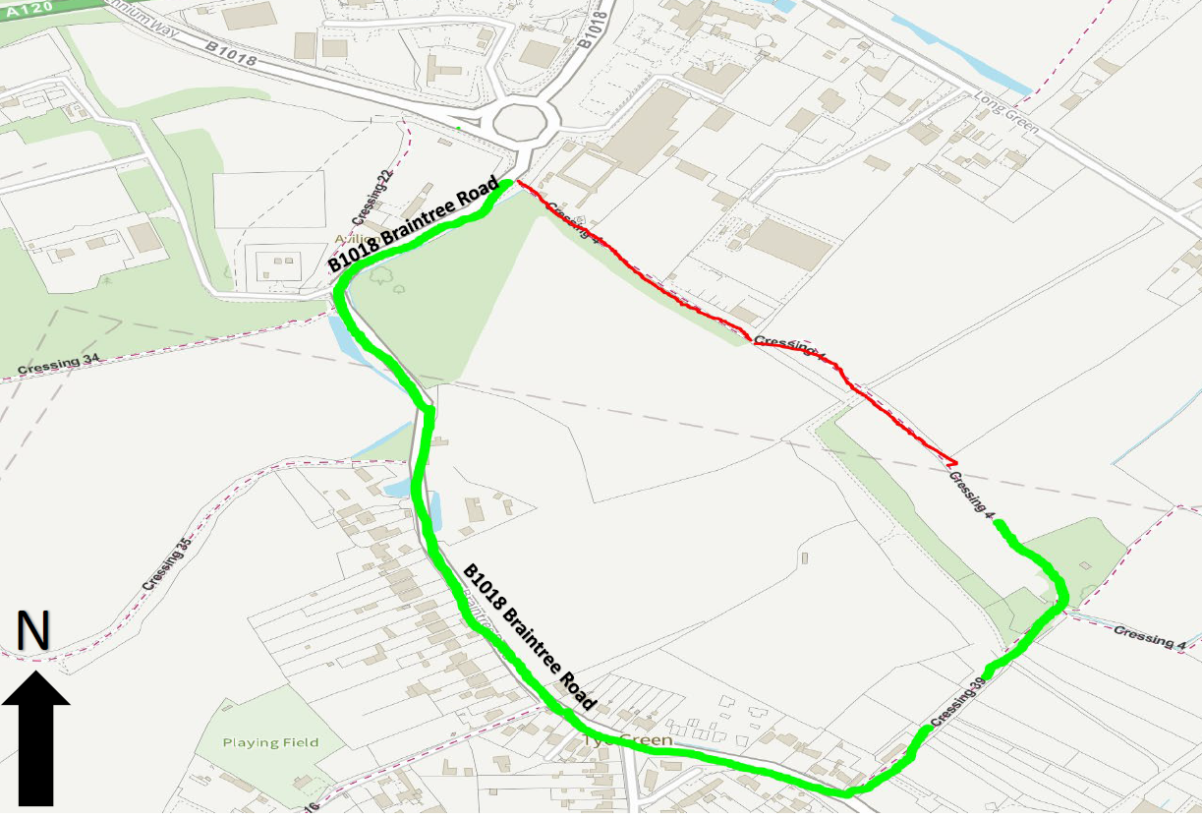The closure is scheduled to commence on 16 May 2024 or where appropriate signs are showing and weather permitting. The closure is required for the safety of the public and workforce while the installation of the link road and drainage is undertaken. This notice will be extended by a 6 month Order.

ESSEX COUNTY COUNCIL
COUNTY HALL
CHELMSFORD, ESSEX

CM1 1QH

TEL: 0345 603 7631

Date: 16 May 2024
County Hall, Essex County Council
Chelmsford Network Assurance

